**Algebra 2 – Review Sec. 4.1 Quiz**

1. Find the domain and zeros for the following functions.
2. f(x) = x3 + 3x2 – 70x
3. f(x) =
4. f(x) =
5. f(x) = 2x2 + 11x – 6
6. f(x) = |x – 4|

1. Find the equation of the following piecewise function. Also find the domain, range, and zeros.

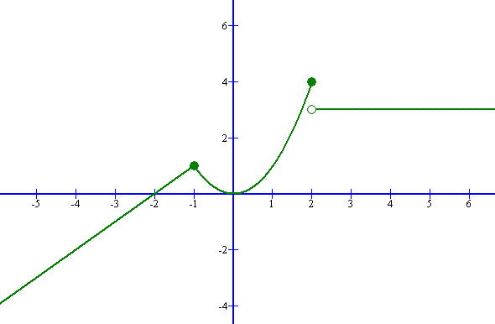

1. Evaluate the following piecewise function at the given values. Then graph the piecewise function and find the domain, range, and zero(s) if any exist.

$f\left(x\right)=\left\{\begin{aligned}4 ,-5≤x<-1 \\ x^{2}-3 ,-1≤x<2 \\ -2x+7 if x≥2\end{aligned}\right.$ $$f\left(10\right)= \\ f\left(0\right)= \\ f\left(-1\right)= \\ f\left(2\right)= \\ f\left(-4\right)= \\ f\left(-7\right)=$$

Domain:

Range:

Zeros:

Review 2

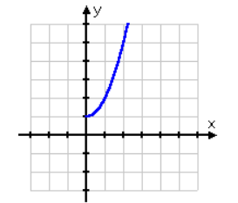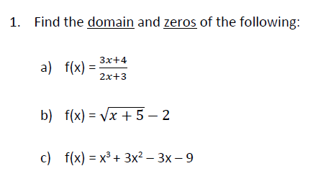

D)

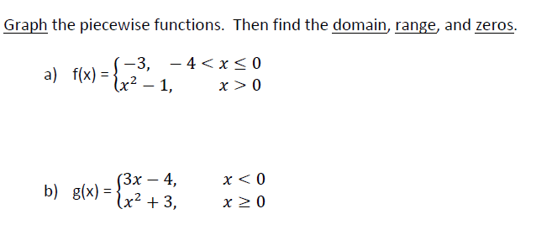

2.

Find f(1) f(-2) f(0)

Find f(4) f(-2) f(0)

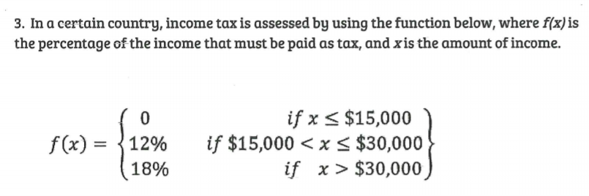

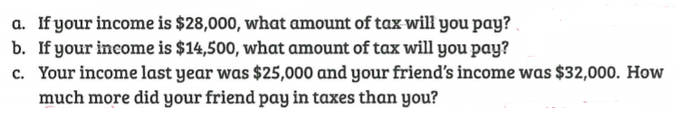

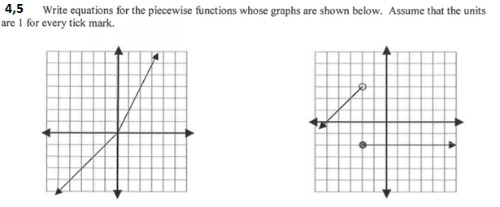

6,7

