- Given the graph below, find the indicated function values
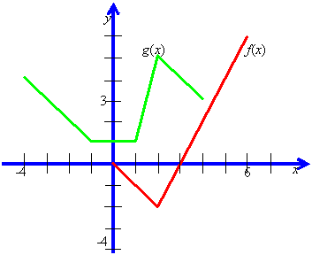

  - (f ° g)(0)
  - (g ° f)(3)

