How to Approach a Linear Programming Problem

A contractor builds two types of homes. The Carolina requires one lot, $160,000 capital,
and 160 worker-days of labor, whereas the Savannah requires one lot, $240,000 capital,
and 160 worker-days of labor. The contractor owns 300 lots and has $48,000,000 available
capital and 43,200 worker-days labor. The profit on the Carolina is $40,000 and the
profit on the Savannah is $50,000. List the corner points of the feasible region
and find how many of each type of home should be built to maximize profit.
Find the maximum profit.

If you hate word problems, this one should be enough to send shivers up your spine. Don't let this intimidate you - we're going to handle this on a step by step basis.
First - look at what the problem wants us to determine
The question is, "...find how many of each type of home should be built to maximize profit."
Specifically, this means determine how many Carolina homes and how many Savannah homes they should build to maximize profit. So now we can name our variables. We'll let
x = the number of Carolina homes to be built
y = the number of Savannah homes to be built
Eventually, we're going to solve for x and y.
Second - develop the system of inequalities based on the limitations
Notice that each house requires a lot, money and labor. However, the contractor only has limited amounts of each of these. So as the contractor decides how many houses to be built, they have to keep in mind these limitations. We'll deal with these now.

Lot Limitation
Each Carolina home requires one lot. We're going to build "x" Carolina homes (remember - x represents the number of Carolina homes). So the number of lots we'll need for our Carolina homes can be represented by the expression: 1x.
Each Savannah home also requires one lot. We're going to build "y" Savannah homes. So the number of lots we'll need for our Savannah homes can be represented by the expression: 1y.
The total number of lots we'll need for both the Carolina and Savannah homes can be represented by the expression: 1x + 1y (or x + y).
The contractor only has 300 lots, so we can now express our first inequality:

Money Limitation
Each Carolina home requires $160,000 capital. If the contractor is going to build "x" Carolina homes, the total capital they will need can be expressed by: 160000x.
Each Savannah home requires $240,000 capital. If the contractor is going to build "y" Savannah homes, the total capital they will need can be expressed by: 240000y.
The total amount of capital the contractor will need for all these homes is therefore: 160000x + 240000y.
The contractor has $48,000,000 of total capital, so we can now express our second inequality:

Worker-day Limitation
Each Carolina home requires160 worker-days of labor. If the contractor is going to build "x" Carolina homes, the total worker-days they will need can be expressed by: 160x.
Each Savannah home requires 160 worker-days of labor. If the contractor is going to build "y" Savannah homes, the total worker-days they will need can be expressed by: 160y.
The total amount of worker-days the contractor will need for all these homes is therefore: 160x + 160y.
The contractor has 43,200 of total worker-days of labor, so we can now express our third inequality:

Reality Check
We've taken care of our three limitations, but we still have one more item to take care. I call it our Reality Check.
Recall that x = the number of Carolina homes to be built. There's a minimum number of homes we can build. That minimum number is 0. Therefore
We can use similar rationale for the Savannah homes. So we write:

We now have our system of inequalities

We want to maximize Profit
Each Carolina home earns $40,000 profit. If the contractor is going to build "x" Carolina homes, the total profit they will get can be expressed by: 40000x.
Each Savannah home earns $50000. If the contractor is going to build "y" Savannah homes, the total profit they will get can be expressed by: 50000y.
The total amount of profit the contractor will receive for all these homes is therefore: 40000x + 50000y.
We want to maximize this expression.

Third - graph this system of inequalities
Start with the two inequalities and . These two inequalities restrict our graph to Quadrant I. So when you draw your axes on your paper, just draw the first quadrant.
Now we'll graph . Determine two points (set x = 0 and solve for y, then set y = 0 and solve for x). Your line should look like this:
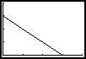The x intercept is (300,0) and the y intercept is (0,300). Remember that we are shading below this line.
Next, we'll graph . Again, determine two points (set x = 0 solve for y, set y = 0 and solve for x).
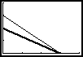Again, we're going to shade below this line.
Next, we'll graph . Again determine the two points.
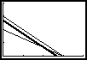. Again, we're going to shade below.
So our feasible region looks as below. (Since I can't figure out how to get the calculator to shade the way I want it, the shading should stop at the x and y axes and only go up to the bottom darkened lines).
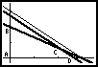I have labeled the four corner points of our shaded region.

Fourth - Determine the coordinates of the corner points
Each corner point is formed by the intersection of two lines from our system of inequalities.
For instance, corner point A uses the two inequalities and . Corner point A is the intersection of the two lines and .
Corner point A is the solution to the system of equations , ! So the coordinates of point A is (0,0).
Corner point B uses the two inequalites and So B is the solution to the system of equations and . This system can be solved by substitution. The coordinates of point B are (0,200).
Corner point C uses the inequalities and . So, corner point C is the solution to the system of equations and . This system can be solved by either elimination or substitution (I will leave the math to you). The coordinates of corner point C are (210 , 60).

Corner point D uses the inequalities and . Therefore, corner point D is the solution to the system of equations and . This can be solved by substitution and you will find the coordinates of point D are (270,0).

Last (hurray!!) - determine the corner point that maximizes our profit
Our profit equation is 40000x + 50000y. We want to maximize this. We're going to select the corner point that maximizes this expression. To determine the desired corner point, we just plug the x and y coordinates into this expression and see which one gives us the biggest answer.

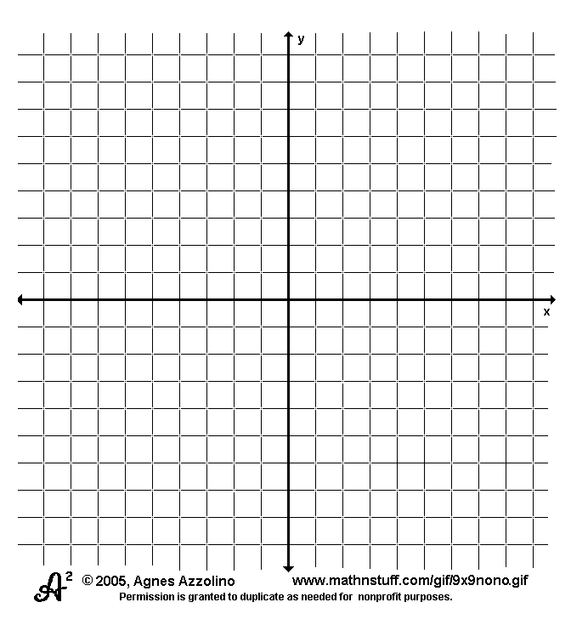

Point A (0, 0 ): 40000(0) + 50000(0) = 0 + 0 = 0 (I bet this won't be the one.)
Point B (0 , 200): 40000(0) + 50000(200) = 0 + 10,000,000 = 10,000,000
Point C (210 , 60): 40000(210) + 50000(60) = 8,400,000 + 3,000,000 = 11,400,000
Point D (270 , 0): 40000(270) + 50000(0) = 10,800,000 + 0 = 10,800,000

Since Point C gave us the biggest profit, our decision would be to build 210 Carolina
homes and 60 Savannah homes. our profit would be $11,400,000.
This is our answer and we are done.

