9. Classify each function as even, odd, or neither.
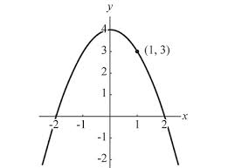
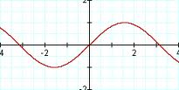
a) b)

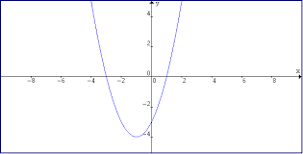
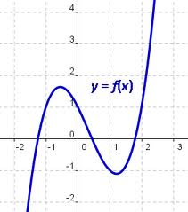
c) d)

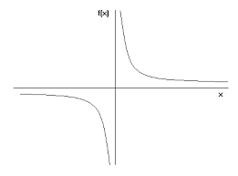
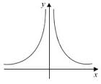
e) f)

g) y = 2x – 10 h) f(x) = 2x – 2x⁵ i) f(x) = 3x⁶ – 4x² + 1

10. The graph of y = f(x) is shown below. Graph each on a separate piece of graph paper.
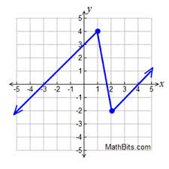
a) y = 2f(x) b) y = f(2x) c) y = ½f(x) d) y = f(½x)

e) y = f(x) – 3 f) y = f(x – 2) g) y = f(x) + 1 h) y = f(x + 2)

